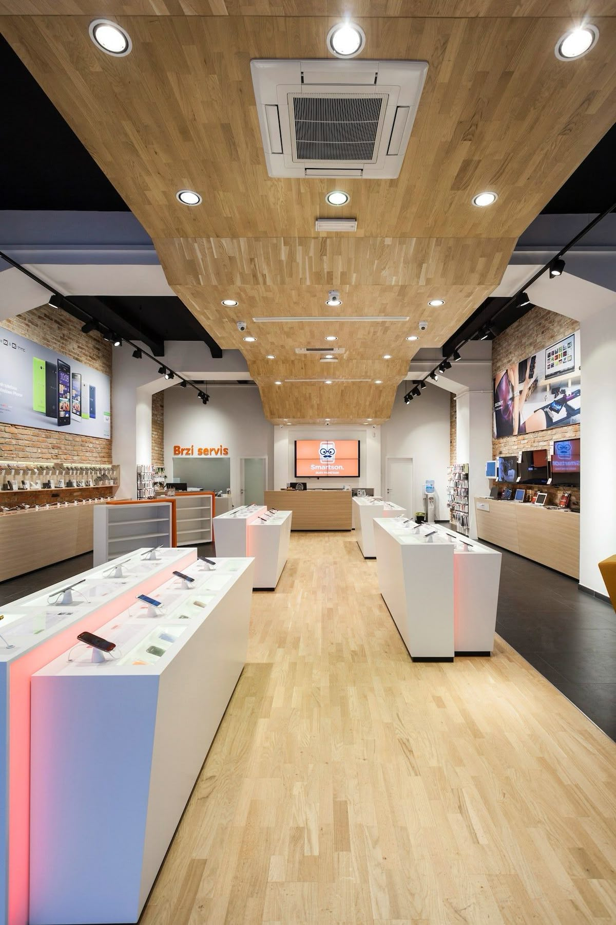
Boikanyo Motshwane
ST10519905 (Group 1)
WEDE5020
Web Development
MR RHULANI KOBENI
Table of Contents

Organisation Overview: 3
Website Goals and Objectives 3
Current Website Analysis (Applicable) 4
Proposed Website Features and Functionality 5
Design and User Experience 5
Technical Requirements 7
Timeline and Milestones 7
Budget 8
References 8

Organisation Overview:

Retail Store Proposals for the Organisation of:
- Name: ZentrixZA Electronics (Real)
Brief History of the organisation
- The organisation had started up the company in the year of 1998 as Zen and Electric Co in their country of origin (South Africa) as their primary service being able to fix and upgrade electronics and to also being able to upgrade software for the cutting edge technology products and devices and today they are one of the most versatile organisations offering almost everything a technology consumer will need in their tech bag for their daily driver use.
Mission and Vision Statement
- Mission
ZentrixZA Electronics is dedicated to bringing you to the future of tech. Our selection of high performance electronics is expertly curated for speed, style and excellence
- Vision Statement
To be the community trusted destination for electronics, repairs, and technology solutions.
Target Audience
- Gamers
- Student
- Professionals
- Small Business

Website Goals and Objectives:

- Website Traffic
Specifically for this website, the main aim is to drive consumer products towards the younger demographic for devices and upgrade of older devices to new devices for online purchase and the older generations for mainly electronics
- Insurance and Guarantee
The Organisation will ensure that the products and service provided will be on warranty and discounts will be applied once the consumer has purchased a product or service
- Generate leads
This is the most valuable point needed is to gain the consumer information by attracting a complimentary service to the end consumer by including social media links to the website’s page or even running ads with in social media platforms or work with influencers.

- Key Performance Indicators (KPIs)
Website Traffic Increase of 250+ visitors per month
Increase the product and service sales to 50+ sales per month
Increase the customer’s engagement on the website for more than 5+ minutes

Current Website Analysis (Applicable):

- Weakness
- Website is currently functioning as is but it is also resource intensive and power hungry with intense shadows and 3D Graphics that makes low-end devices to not run efficiently.
- Strengths
- The website has valuable Information that can be able used to attract the end consumer but is bombarded with intense colour and graphics that is not needed
- Improvements
The main improvements needed for the website is to have a minimal design (OPEN AND FLAT) Design that will encompass bold colours with minimal distractions and gain more attention in which will generate leads

Proposed Website Features and Functionality:

- The Main Features for this Website must include
Home- Everything Else from the options that are mentioned below the home page (Including My Cart, Account)
Products- Core Products being offered (Laptops, Smartwatch, Phones, TVs)
Repairs-All kind of Repairs
Services Offered-Software Upgrades, Device Upgrades, Accessories
About US – Contacts, History, Special Offers

Design and User Experience:

- The Overall design of the website must have a professional modern look that will give an attention grabbing to the end consumer as a whole as the brand will have to be bold and open to the public about the service they provide in the electronics industry.
- Colour: Brown: Hex code #BB8D6F and Grey: Hex Code #686A6C
- Typography: Calibri, Roboto or Open Sans
- Layout/Design: Open and Flat Design (Minimal Style that has a professional colours, clean typography while using the 2D Shapes with flowing animations that will encompass shadows and gradients with simple UI elements like flat buttons and geometric shapes.
- User Experience Considerations: Side bar Navigation in accordance to the Flat Design and to also adapt to the colour scheme Picture for the Website:
Picture for the Website: Low Fidelity Wireframe

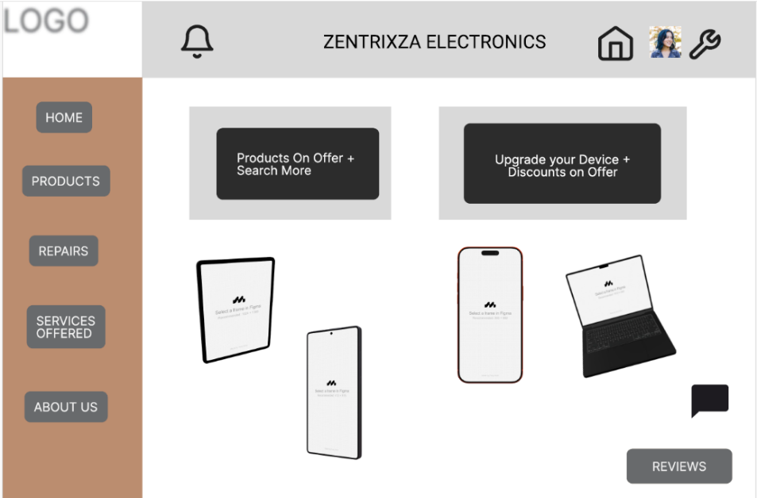

- Hierarchy for the Information
- Logo
- Business Name
- Slogan
- Notification
- Home/Return
- Profile
- Settings

- Side bar Navigation
- Home
- Products
- Repairs
- Services Offered
- About Us

- Main
- Featured Products
- Upgrade or Get a new device

- Other
- Reviews
- Communication Channel Bubble

Technical Requirements:

The technical requirements needed for the hosting the website it should be:
Short and easy to remember.
Connected to the chosen web hosting service.
Registered with an accredited domain registrar.
(zentrixza.co.za) – Chosen Name
- Programming Language Used (Front-End)
CSS3
JavaScript
HTML5
- Frame Works
BootStrap five
- Hosting
Utilising a shared type based web-hosting site with a .co.za do domain, SSL Certificate, including daily backups also include the Uptime to ensure the website remains accessible and include the SSD storage for a faster load-times when accessing the website

Timeline and Milestones:

- Realistic Timeline (According to the Subject Submission Date)
PART 1
Week – 1/5 Planning and Research (Proposal) (Approval of the proposal)
Week – 2 Researching and Development (Including building of Website from HTML)
Milestone Completed and Approved
- Research and Development – (Requirements of website goals and target audience and website content)
- Prototype is completed
- Basic Structure of Website is completed
Week – 3 Submission of Part 1 (Date: 14 August)

PART 2
Week 4 – UI and Coding (Website Design from CSS and JavaScript)
Week 4-5 Development and testing of the website
Milestone Completed and Approved
- Design of the User Interface for the website
- Testing is completed and fully developed and ready for use
Week 6 - Submission of Part 2 (Date: 18 September)

PART 3
Week 7- Deployment and Documentation
Milestone Completed and Approved
- Website is fully developed and ready for use
- Documentation is ready for reading for the development of the website
Week 8-10 Final Submission of Website (Part 3) (Date: Unknown)

Budget:

Standard / E-Commerce Websites Option Selected
- Development ≈ R11 750
- Hosting ≈ R3750
- Maintenance (Optional Extra Added ≈ R1500
- Upgrades - Optional Extra Added ≈ R4750
- Domain ≈ R250
Full development Costs of the website ≈ Total ≈ R22000
Annual Costs = R22000*12 ≈ R264000

References:
Zentrix Electronics, 2021, Electronics Website (Targeted Organization) [Online] Available at: <https://www.zentrixeletronics.com/> [Accessed on 29 July 2026]

@zentrixelectronics (wix), 2026, Electronics store. [Facebook], March 2026, Available at: <https://web.facebook.com/wix?_rdc=1&_rdr#> [Accessed on 01 August 2026]

Digital Platforms, 2008, Electronics Website Available, 6 Phases of the website design and development process at :< https://www.digitalplatforms.co.za/6-phases-of-the-web-site-design-and-development-process/> [Accessed on 2 August 2026]

Web Development Technologies - A Practical Guide, 2024, my annual guide to every web development technology that you can think of. We cover everything including frontend, backend, full stack, DevOps and more.,[Video Online] Available at <https://www.youtube.com/watch?v=8sXRyHI3bLw> [Accessed on 3 August 2026].

Back to bugherd.com, 2023, The Art of Website Project Management: A Comprehensive Guide [Online], Available at: <https://bugherd.com/blog/website-project-management> [Accessed on 2 August 2026]

W3Schools, 2026, HTML Responsive Web Design,[online], Available at:<https://www.w3schools.com/html/html_responsive.asp> [Accessed on 5 August 2026]

